Multimodal Hospitality Creator

  - Course Name: Generative AI

Institution Name: Medicaps University – Datagami Skill Based Course

Student Name(s) & Enrolment Number(s):
Sr no | Student Name | Enrolment Number
1 | HARSH RAI | EN22CS301393
2 | HEMANT DHAKAD | EN22CS301421
3 | GAURAV DWIVEDI | EN23CS3L1008
4 | HIMANI JAISWAL | EN22CS301423
5 | GOUTAM VERMA | EN22CS301375
6 | HARSHWARDHAN YADAV | EN22CS301416

Group Name:12D4
Project Number: GAI-48
Industry Mentor Name: Suraj Nayak
University Mentor Name: Divya Kumawat
Academic Year: 2025–2026

Problem Statement
The hospitality industry heavily relies on conceptual visualization for hotels, resorts, restaurants, and themed interiors. Traditional concept development requires manual design effort, architectural visualization tools, and extended design cycles. This creates time and cost inefficiencies, especially during early-stage ideation.
The problem addressed in this project is to design and implement a multimodal Generative AI system capable of transforming simple textual prompts into both descriptive narratives and high-quality visual representations. The system must integrate Large Language Models (LLMs) and image generation models to create immersive hospitality design concepts efficiently.

Project Objectives
The primary objectives of this project are:
- To design a multimodal AI-based hospitality concept visualization system.
- To integrate an LLM API for prompt enhancement and descriptive generation.
- To generate high-fidelity images using diffusion-based image generation models.
- To implement a vector database for embedding storage and semantic similarity.
- To develop an interactive web-based interface using Streamlit.
- To ensure scalability, security, and performance through modular architecture.

Scope of the Project
The scope of this project includes:
- Text-to-text processing using LLM APIs.
- Text-to-image generation using diffusion models.
- Hospitality concept visualization (luxury hotels, resorts, interiors, themed environments).
- Embedding-based semantic storage.
- Web-based interaction system.

Proposed Solution
The proposed solution is a modular AI-powered system that integrates text-based AI and image-based AI through REST APIs.
The workflow is as follows:
- The user enters a hospitality-related prompt via a Streamlit web interface.
- The backend processes and structures the input.
- The prompt is sent to a Large Language Model API (Gemini) for enhancement.
- The system generates embeddings and stores them in a vector database.
- The enhanced prompt is forwarded to an image generation model (HuggingFace diffusion).
- The generated image and descriptive output are displayed to the user.
This architecture ensures separation of concerns, modularity, and scalability.

Key Features
- AI-driven hospitality concept generation
- Prompt enhancement using LLM
- High-resolution image generation
- Vector embedding storage
- Semantic similarity search
- Streamlit-based interactive interface
- Secure API communication
- Scalable modular backend design

Overall Architecture / Workflow
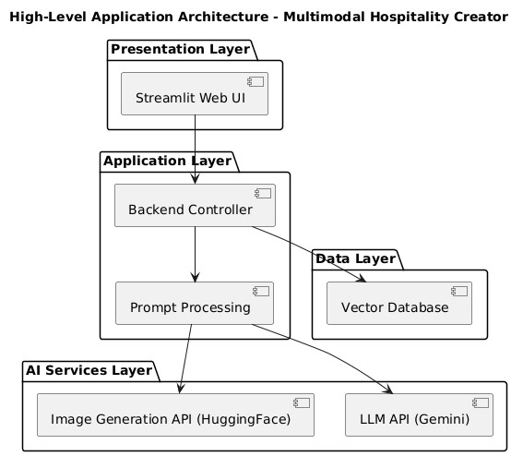

The system follows a layered architecture:

1. Presentation Layer
Developed using Streamlit, this layer handles:
- User input
- Output visualization
- Session management

2. Application Layer
Handles:
- Prompt processing
- API integration
- Data formatting
- Error handling
3. AI Services Layer
- LLM API for narrative generation
- Image generation API for visual output
4. Data Layer
- Vector database for storing embeddings
- Logging and temporary storage
Workflow Summary
User Input → Backend Processing → LLM Enhancement → Embedding Storage → Image Generation → Output Display

Tools & Technologies Used
- Python (Core backend development)
- Streamlit (Web Interface)
- Gemini API (LLM Processing)
- HuggingFace Diffusion Models (Image Generation)
- Vector Database (Embedding Storage)
- REST APIs
- JSON Communication
- HTTPS Secure Protocol

Results & Output
Screenshots / Outputs
Main Page:
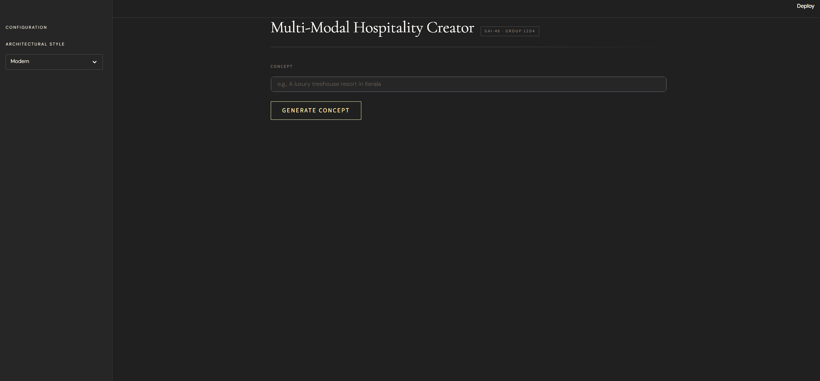

Prompt Interface:
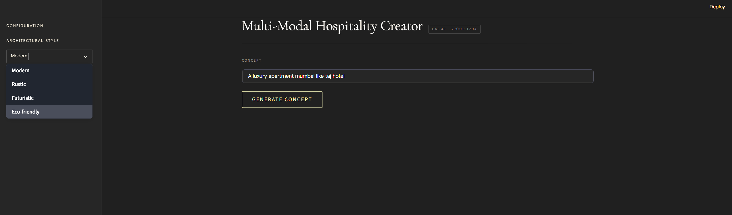

Generated Output:
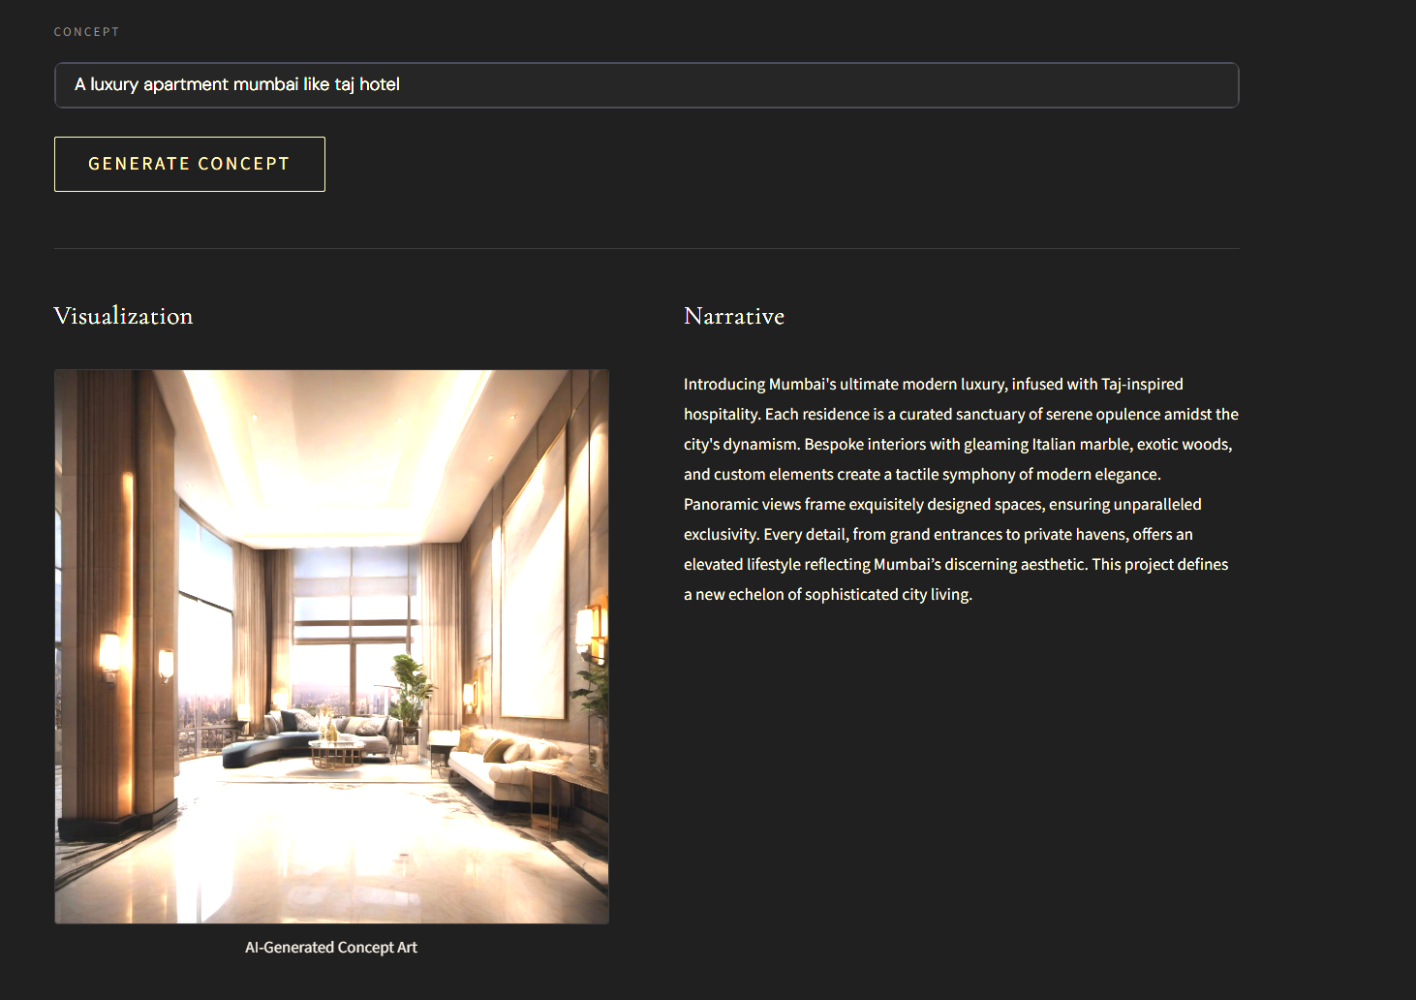

Generated Image
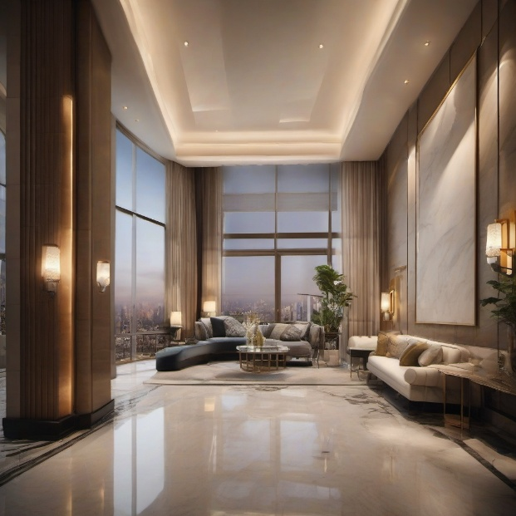

Generative Narrative:
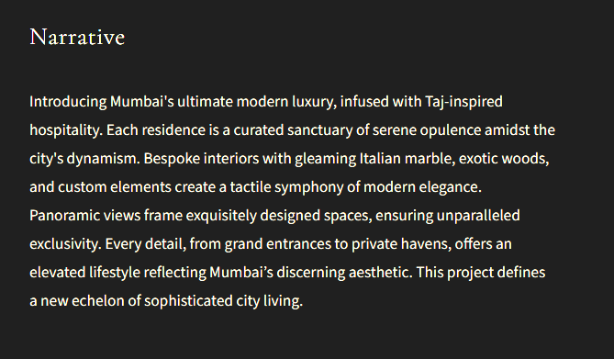

Reports / Dashboards / Models
The system produces:
- AI-generated hospitality concept descriptions.
- High-fidelity visual representations of hotels and resorts.
- Structured prompt transformations.
- Embedding-based semantic data storage.

Key Outcomes
- Successfully implemented a multimodal AI system.
- Integrated LLM and image generation APIs.
- Achieved real-time concept visualization.
- Designed modular architecture supporting scalability.
- Demonstrated semantic embedding storage.

Non-Functional Implementation Summary
Scalability
The system can integrate additional models or cloud-based storage without structural changes.
Reliability
API error handling and response validation ensure consistent performance.
Security
API keys stored securely using environment variables and HTTPS-based communication.
Performance
Optimized prompts, caching strategies, and efficient embedding search reduce latency.

Conclusion
The Multimodal Hospitality Creator successfully demonstrates the integration of text-based and image-based generative AI models for hospitality concept visualization. By combining LLM-driven narrative enhancement and diffusion-based image generation, the system enables rapid and immersive design ideation.
The project highlights the power of multimodal AI in accelerating creative workflows and showcases practical implementation of AI APIs, vector databases, and modular web architecture. It serves as a foundation for future AI-driven design systems in hospitality and related industries.

Future Scope & Enhancements
- Cloud deployment for multi-user support.
- Advanced style customization and theme presets.
- Integration of 3D rendering engines.
- AI-based recommendation system using embedding similarity.
- Mobile application support.
- Real-time prompt refinement and interactive editing.
- Integration with AR/VR visualization systems.

